Exercise Regulates Fatty Acid Synthesis In The Mouse Brain And Promotes Anxiolytic Effect

Arkadiusz Liśkiewicz^{1,2}, Marta Przybyła^{1,3}, Anna Wojakowska⁴, Łukasz Marczak⁴, Katarzyna Bogus⁵, Marta Nowacka-Chmielewska^{1,3}, Daniela Liśkiewicz^{1,3}, Andrzej Małecki¹, Jarosław Barski³, Joanna Lewin-Kowalik², Michal Toborek^{1,6}

¹Laboratory of Molecular Biology, Faculty of Physiotherapy, The Jerzy Kukuczka Academy of Physical Education, Katowice 40-065, Poland
²Department of Physiology, Medical University of Silesia, Katowice 40-752, Poland
³Department for Experimental Medicine, Medical University of Silesia, Katowice 40-752, Poland
⁴Institute of Bioorganic Chemistry, Polish Academy of Sciences, Poznan 61-704, Poland
⁵Department of Histology, School of Medicine in Katowice, Medical University of Silesia, Katowice 40-752, Poland
⁶Department of Biochemistry and Molecular Biology, University of Miami School of Medicine, 1011 NW 15th Street, Miami, FL, 33136, USA

Supplementary information contains:
Supplementary Fig. 1. Actinogram of running activity
Supplementary Table 1. List of significantly different compounds discriminated as the result of metabolomic profiling

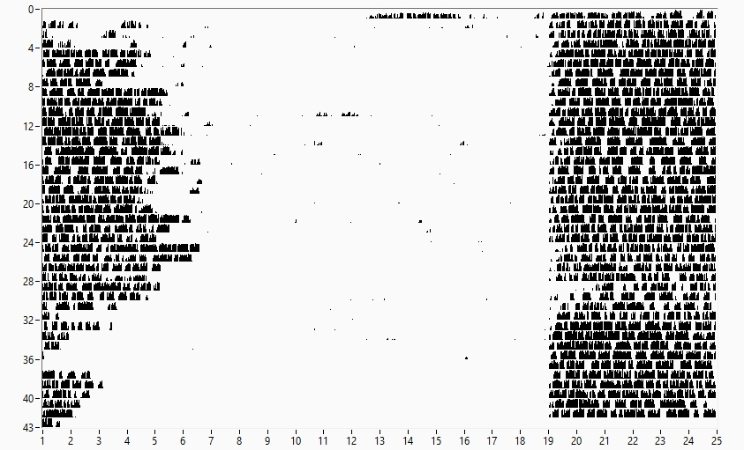
Supplementary Figure 1. Representative actinogram of a wheel running mouse. Active episodes are depicted as black dots during a 43 day running period (y axis). X axis presents the time of day/night cycle (12:12), with light phase lasting from 7 to 19, when dark phase began. Mice were active predominantly during dark phase of the cycle.
Table 1. Metabolome profile of the hippocampus and frontal cortex of the running and inactive mice (n=6-7). Data are presented as mean +/- S.D. (Student T-test) or median with min. to max. (U Mann-Whitney test; marked by italics).

 | Hippocampus |  |  |  | Frontal cortex |  |  |  | Replib, Mainlib, Fiehn library identification
Compound | Inactve | Runnners | P value | Runnners as % of inactive | Inactve | Runnners | P value | Runnners as % of inactive
Compounds significantly changed in hippocampus
Creatinine | 19216026  (±10617256) | 8509740  (±4709227) | 0.048 | 44 | 7265821  (±4589836) | 12908408  (±8876126) | 0.16 | 178 | 1-Methyl-N,N-bis(trimethylsilyl)-4-[(trimethylsilyl)oxy]-1H-imidazol-2-amine
Gluconic acid | 374548  (±71522) | 239732  (±36544) | 0.0021 | 64 | 322179  (±41093 | 361408  (±111339 | 0.4 | 112 | D-Gluconic acid, 2,3,4,5,6-pentakis-O-(trimethylsilyl)-, trimethylsilyl ester
Uridine 5'-monophosphate | 2894007  (±379676) | 2155021  (±289947) | 0.004 | 74 | 2343224 (±410887) | 2575199 (±563463) | 0.4 | 110 | 2(1H)-Pyrimidinone, 1-[2,3-bis-O-(trimethylsilyl)-?-D-ribofuranosyl]-4-(trimethylsiloxy)-, 5'-[bis(trimethylsilyl) phosphate]
Picolinic acid | 62813  (±40081) | 148910  (±53144) | 0.0100 | 237 | 142709  (±65263) | 114137  (±99952) | 0.54 | 80 | Picolinic acid, trimethylsilyl ester
L-Valine | 5049080  (±582330) | 4286543  (±371746) | 0.022 | 85 | 4504077 (2818898-4804983) | 4445456 (3149737-4533205) | 0.46 | 99 | L-Valine, N-(trimethylsilyl)-, trimethylsilyl ester
Acetylated lysine | 1969639 (198297-2246426) | 2288958 (1950077-2595534) | 0.0367 | 116 | 1406630  (±268706) | 1526029  (±190991) | 0.36 | 108 | N-α-Acetyl-L-Lysine, N,N-trimethylsilyl-, trimethylsilyl ester
Sedoheptulose 7-phosphate | 38833  (±5240) | 53417  (±13025) | 0.0291 | 138 | 43971  (±17000) | 45244  (±11448) | 0.87 | 103 | D-Altro-2-Heptulose, 1,3,4,5,6-pentakis-O-(trimethylsilyl)-, O-methyloxime, 7-[bis(trimethylsilyl) phosphate]
4-Ketoglucose | 79685  (±22996) | 113598  (±20058) | 0.017 | 143 | 62214  (±16637) | 61060  (±22534) | 0.92 | 98 | 4-Ketoglucose, bis(O-methyloxime), tetrakis(trimethylsilyl)
Urea | 40006466  (±15247368) | 57624242  (±7687600) | 0.03 | 144 | 46106245  (±19065836) | 48916564  (±21227194) | 0.8 | 106 | Urea, N,N'-bis(trimethylsilyl)-
Fructose 6-phosphate | 142273 (52400-207948) | 231833 (173510-539473) | 0.026 | 163 | 168477  (±135215) | 153036  (±50082) | 0.78 | 91 | d-Fructose, 1,3,4,5-tetrakis-O-(trimethylsilyl)-, o-methyloxime, 6-[bis(trimethylsilyl) phosphate]
3-Phosphoglycerate | 587120  (±180032) | 1034352  (±328683) | 0.0152 | 176 | 514515  (±241765) | 437913  (±127916) | 0.47 | 85 | Propanoic acid, 3-[[bis[(trimethylsilyl)oxy]phosphinyl]oxy]-2-[(trimethylsilyl)oxy]-, trimethylsilyl ester, (S)-
Galactose-6-phosphate | 103105  (±26195) | 198350  (±73226) | 0.0133 | 192 | 123095  (±95459) | 108068  (±25039) | 0.69 | 88 | d-Galactose, 2,3,4,5-tetrakis-O-(trimethylsilyl)-, O-methyloxime, 6-[bis(trimethylsilyl) phosphate]
D-Pinitol | 19037  (±9074) | 82033  (±8408) | <0.0001 | 431 | 37701 (17100-75501) | 49999 (26500-179896) | 0.38 | 133 | D-Pinitol, pentakis(trimethylsilyl) ether
Compounds significantly changed in frontal cortex
L-Arabitol | 262723  (±48223) | 210468  (±37727) | 0.05 | 80 | 359331 (±68652) | 242379 (±41575) | 0.0023 | 67 | L-(-)-Arabitol, pentakis(trimethylsilyl) ether
Glycerol | 11531 (3521-3384779) | 2172227 (1913749-2677249) | 0.31 | 18838 | 2371716 (1274323-3190387) | 1634706 (6576-2449235) | 0.038 | 69 | Glycerol, tris(trimethylsilyl) ether
D-Ribose | 42929  (±21655) | 47718  (±6374) | 0.61 | 111 | 53286  (±7715) | 38814  (±12994) | 0.026 | 73 | d-Ribose, 2,3,4,5-tetrakis-O-(trimethylsilyl)-, O-methyloxime
Aminoadipic acid | 236170  (±54153) | 182550  (±43884) | 0.08 | 77 | 388013  (±87431) | 284100  (±70208) | 0.03 | 73 | α-Aminoadipic acid, triTMS
Niacinamide | 4040615  (±1648891) | 3558015  (±571339) | 0.51 | 88 | 2184893  (±463775) | 1585933  (±453801) | 0.031 | 73 | Niacinamide, N-trimethylsilyl-
Phosphoetanoloamine | 15854767  (±6799777) | 18982645  (±1870929) | 0.3 | 120 | 22555158  (±2736147) | 17161754  (±5569745) | 0.04 | 76 | Phosphoric acid, 2-[bis(trimethylsilyl)amino]ethyl bis(trimethylsilyl) ester
Uridine | 782298  (±259524) | 797386  (±115792) | 0.8981 | 102 | 808964  (±191024) | 617083  (±121548) | 0.045 | 76 | Uridine, 2',3',5'-tris-O-(trimethylsilyl)-
alpha-Ketoglutaric acid | 26960632  (±5447839) | 30972231  (±4172623) | 0.17 | 115 | 21201955  (±2826245) | 16574158  (±2867022) | 0.014 | 78 | 2-Ketoglutaric acid ditms
Fumaric acid | 2186058 (1473790-5652666) | 2046656 (1631311-2123629) | 0.45 | 94 | 2117793 (1982996- 3344989) | 1747135 (1425859- 2057028) | 0.0083 | 82 | 2-Butenedioic acid (E)-, bis(trimethylsilyl) ester
Citric acid | 5447019  (±1334094) | 5442578  (±682500) | 0.99 | 100 | 6769390  (±728139) | 5535689  (±1158222) | 0.04 | 82 | 1,2,3-Propanetricarboxylic acid, 2-[(trimethylsilyl)oxy]-, tris(trimethylsilyl) ester
Phenylalanine | 1352836  (±288170) | 1346592  (±209568) | 0.96 | 100 | 1225972  (±90679) | 1018852  (±193422) | 0.025 | 83 | N,O-Bis-(trimethylsilyl)phenylalanine
Butane, 1,2,3,4-tetrakis[(trimethylsilyl)oxy]- | 144539 (2491-166897) | 144982 (122949-172939) | 0.63 | 100 | 134309 (116567-209865) | 112417 (4084-130655) | 0.026 | 84 | 3,8-Dioxa-2,9-disiladecane, 2,2,9,9-tetramethyl-5,6-bis[(trimethylsilyl)oxy]-, (R*,S*)-
Malic acid | 3502978  (±955127) | 3834061  (±783187) | 0.51 | 109 | 4301218  (±455259) | 3725586  (±505600) | 0.044 | 87 | Butanedioic acid, [(trimethylsilyl)oxy]-, bis(trimethylsilyl) ester
gamma-Aminobutyric acid (GABA) | 114044024  (±16202564) | 111500000  (±8803408) | 0.74 | 98 | 97189694 (91813311-113490791) | 84872862 (12608558-93502396) | 0.0023 | 87 | Butanoic acid, 4-[bis(trimethylsilyl)amino]-, trimethylsilyl ester
Pelargonic acid | 116275  (±17167) | 101812  (±18170) | 0.17 | 88 | 108335  (±22876) | 141788  (±31963) | 0.044 | 131 | Nonanoic acid, trimethylsilyl ester
Compounds significantly changed in hippocampus and frontal cortex
Methyl arachidonoic acid | 107115 (86499-496867) | 79850 (52499-131117) | 0.035 | 75 | 85192  (±59230) | 26518  (±20591) | 0.029 | 31 | 5,8,11,14-Eicosatetraenoic acid, methyl ester, (all-Z)-

